Mr SGs Heating Processes Notes

-While the effects of heating a substance can be readily observed, it is extremely difficult to directly observe the nature of heat itself
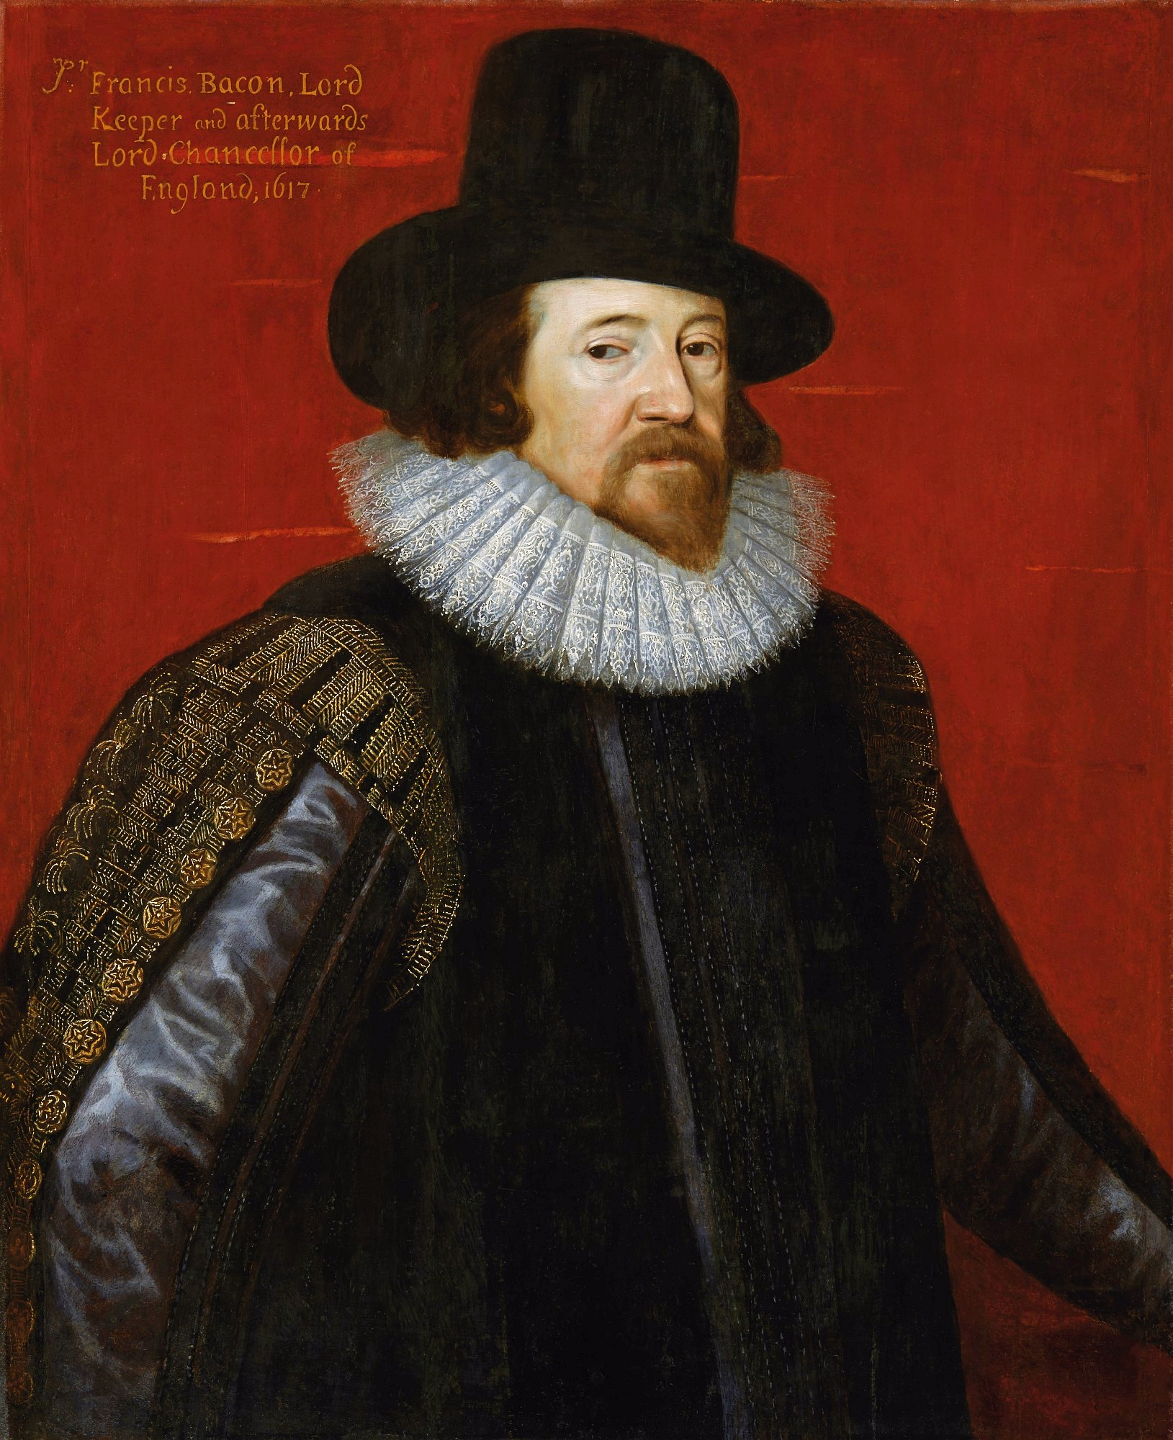

-In the Middle Ages, people believed in the caloric theory of heat which stated that heat was a fluid that filled the spaces between a substance’s particles and could flow between substances

-In the 16th century, Sir Francis Bacon proposed that heat was the rapid vibration of the particles within a substance

-This proposal predated the discovery of molecules and the proposal of the kinetic particle model

-We know understand the temperature of a substance is a measure of the kinetic energy of the particles within the substance

Kinetic Particle Model (Kinetic Theory)

-The kinetic particle model is used to explain the behaviour and properties of matter, including how it responds to heating and cooling

-It is based on the following assumptions:

-all matter is made up of very small particles (atoms or molecules)

-the particles are in constant motion

-collisions between particles are perfectly elastic (do not result in a loss of E_{k})

-there are forces of attraction and repulsion between particles (interparticle forces)

-the distances between particles of a gas are large compared with the size of the particles

-When the temperature of a substance increases, the kinetic energy of the particles within that substance increases

-The properties of solids, liquids and gases can be explained by relative amounts of kinetic energy of the particles and the strength of the interparticle forces

Solids

-In solids, the attractive forces hold the particles in fixed positions, while the repulsive forces prevent the lattice from collapsing
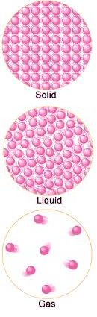

-Particles within the solid vibrate around their equilibrium positions, giving solids a fixed volume and shape

Liquids

-In liquids, the particles have greater kinetic energy than those in a solid and the interparticle forces are weaker

-The particles can move past one another, causing liquids to have a variable shape/take the shape of their container

-Liquids have a fixed volume, which is generally slightly larger than the volume they would occupy as a solid

Gases

-Gas particles have a greater kinetic energy than solids or liquids and weaker attractive forces between particles

-This causes the particles to move in rapid, random straight lines until they collide with other particles or the wall of their container

-Collisions between particles are assumed to be elastic due to the high particle speeds and low attractive forces

-Gases have a variable shape and a variable volume

Heat and temperature

-In physics, it is important to be able to distinguish between temperature, heat and internal energy

-Temperature (T): average kinetic energy of particles in a substance

-Heat (Q): thermal energy transferred from an object at a higher temperature to an object at a lower temperature

-Internal energy (U): total kinetic and potential energy of the particles within a substance

-The kinetic energy component of internal energy is the kinetic energy due to the random movement of individual particles within the substance, NOT the net movement of the substance as a whole

Temperature (T)

-The temperature of an object can be measured with a thermometer

-These generally contain a bulb filled with a liquid (often alcohol or mercury) connected to a capillary marked with scale divisions

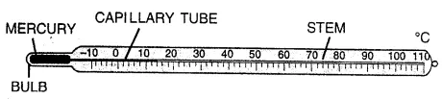

- The thermal expansion of the liquid in the bulb forces the liquid further up the capillary as the temperature increases

-Temperature can be measured in arbitrary or absolute scales

Arbitrary temperature scales

-Arbitrary scales are those where the scale is constructed by assigning arbitrary values to readily reproducible temperatures

-In the Fahrenheit scale, 0ºF was assigned to the freezing point of a solution containing equal parts ammonium chloride, water and ice, and 96ºF was assigned to the human body temperature

-The magnitude of 1ºF is then 1/96 the difference between these temperatures
-In the Celsius scale, 0ºC is assigned to the freezing point of water and 100ºC is assigned to its boiling point

-Both of these scales are arbitrary because they contain negative values (e.g. doubling the E_{k} will not result in a doubling of temperature)

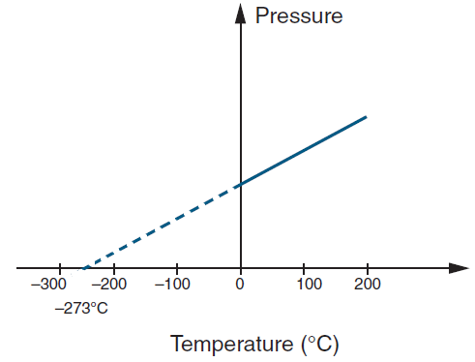
Kelvin: Absolute temperature

-For a temperature scale to be absolute, it cannot have negative values

-Zero on the scale needs to correspond to the coldest temperature theoretically possible (e.g. a complete absence of kinetic energy)

-This temperature can be calculated by plotting the temperature of a gas against its volume and tracing the line back to calculate the temperature at which the gas would occupy a volume of zero

-This temperature is known as absolute zero

Absolute zero = 0K = -273.15ºC (generally approximated to -273 ºC)

-The kelvin scale of temperature is based on absolute zero and the triple point of water, the point where the pressure and temperature (~0.01ºC) allow water to exist in the solid, liquid and gaseous states

-The magnitude of one kelvin is the same as the magnitude of one degree Celsius, but the lowest temperature on each scale has a different value

T (K) = T(ºC) + 273 T(ºC) = T (K) + 273

-The kelvin scale must be used for Physics calculations involving temperature

Heat transfer

-Heating and cooling occur when thermal energy (Q) flows between objects at different temperatures

-When two objects at different temperatures are in thermal contact (when heat can flow between them), heat energy flows from the hotter object to the cooler object

-When the two objects reach the same temperature, they are said to be at thermal equilibrium as there is no net thermal energy transfer between them

Zeroth Law of Thermodynamics: “If two systems are in thermal equilibrium with a third system, then they are in thermal equilibrium with each other”

-This is often stated as “Two objects in thermal equilibrium with each other must be the same temperature”

Internal energy (U)

-Internal energy refers to the sum of the kinetic and potential energies of the particles within a substance

-All particles possess kinetic energy (E_{K}) due to their motion and potential energy (E_{P}) due to their position and the forces between particles

-When particles move further apart or change state, the energy used to overcome the interparticle forces is converted into potential energy

-When a substance is heated, its internal energy increases

-If the heating causes an increase in temperature, it gains kinetic energy and if it causes expansion or a change of state, it gains potential energy
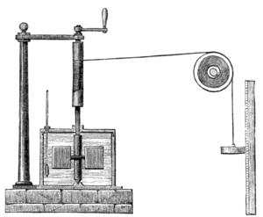

-When mechanical work is done on a system, it increases the internal energy of the system and when mechanical work is done by a system, its internal energy decreases

-James Prescott Joule measured the relationship between mechanical work and heat energy by using falling masses to drive a paddle wheel that stirred water in an insulated can

-Friction between the paddle wheels and the water caused an increase in its temperature

First Law of Thermodynamics: “When energy passes into or out of a system as work or heat, the systems internal energy changes in accord with the law of conservation of energy”

-A systems change in internal energy (U) is equal to the heat added to the system (Q) plus the work done on the system (W)

ΔU = Q + W
Specific Heat Capacity

-Different objects will change temperatures at different rates when heated

-If a pot of water is heated on a stove, the thermal energy added to the water (Q) increases as the heating time increases

-If the mass of water in the pot is doubled, it will take twice as long to achieve a given temperature increase
Q $∝$ m

-The longer the water is heated, the more its temperature will increase

Q $∝$ ΔT

-These relationships hold true for all materials, but the exact amount of heat required to produce a given temperature increase in a given mass of a material varies (e.g. it takes more heat energy to increase the temperature of 1 kg of water by 10 ºC than it does for 1 kg of methylated spirits)

Specific heat capacity (c): The specific heat capacity of a material is the amount of energy (in joules) required to change the temperature of 1 kg of a material by 1 K (1 ºC)

-The specific heat capacity of a material can be determined experimentally and is different for a material in different states (e.g. c_{water} ≠ c_{ice})

-Knowing the heat capacity of a material allows you to calculate the energy required to cause a given temperature change in a given mass of a material

Q = mcΔT

where Q is the heat energy transferred in J, m is the mass in kg, c is the specific heat capacity in J kg⁻¹ K⁻¹ and ΔT is the temperature change in K (or in ºC)

Specific heat capacities of different materials

-The heat capacities of different materials can vary greatly

-Liquid water has a particularly high heat capacity meaning that it takes a large amount of energy to change its temperature

-This makes it useful as a coolant in automotive cooling systems, as it will remove a large amount of heat from a hot material before reaching thermal equilibrium

-Metals with low heat capacities but high melting points like iron are useful for cookware as they are excellent conductors of heat and their low heat capacity minimises the heat that is “wasted” in heating up the cookware rather than the food inside

Latent Heat

Heating and cooling curves
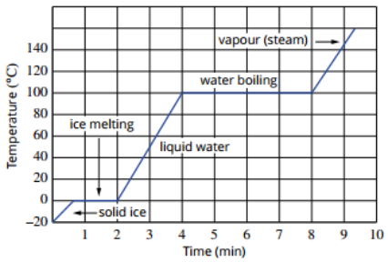
-When water is heated, it gains thermal energy, causing its temperature to increase

-When it reaches a temperature of 100 ºC, the temperature stops increasing as the water begins to boil

-The temperature remains constant until all the water has changed state

-The water is still gaining internal energy (U) as it is heated, but its temperature is not increasing

-Internal energy is the sum of the kinetic and potential energies of the particles within a substance, so the water must be gaining potential energy if its temperature (its mean E_{k}) is constant

-Whenever a substance goes from a solid to liquid or a liquid to a gas, it must gain potential energy

Latent Heat (L)

-Latent (meaning hidden) heat is the energy required to change the state of a substance

-Different substances have different latent heats due to differences in the arrangements of particles and the strength of their interparticle forces

-As with specific heat capacity, the latent heat of a substance can be experimentally determined by measuring the energy required to change the state of a given mass of a substance (without changing its temperature)

-Knowing a substance’s latent heat makes it possible to calculate the energy required to change the state of a given mass of the substance

Q = mL

where Q is the heat energy transferred in J, m is the mass in kg, and L is the latent heat
in J kg⁻¹

Latent heat of fusion
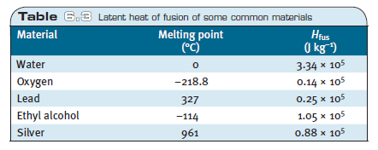

-To change state from a solid to a liquid, potential energy is gained as the interparticle forces are reduced and the particles move further apart

-When a solid melts, this potential energy is released as heat

Latent heat of fusion (L_{fusion}): The energy released when 1 kg of a substance melts/ the energy required to change 1 kg of a substance from a solid to a liquid
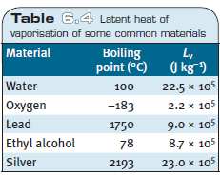

Latent heat of vaporisation

-When a substance changes state from a liquid to a gas, potential energy is gained as it overcomes the interparticle forces that hold adjacent particles together so that the particles can move further apart

Latent heat of vaporisation (L_{vaporisation}): The energy required to change 1 kg of a substance from a liquid to a gas/ the energy released when 1 kg of a substance condenses

Refrigeration
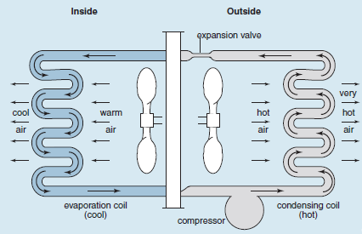

-Refrigerators and air-conditioners are heat pumps that move thermal energy from one area to another

-A refrigerant gas is pumped through a pipe that passes inside and outside the refrigerator

-There is a compressor and an expansion valve within the system to force the refrigerant to change states

-As the refrigerant enters the inside of the refrigerator, it passes through an expansion valve allowing the liquid refrigerant to become gaseous

-As it does this, it absorbs thermal energy from the air in the fridge to provide the latent heat of vaporisation of the refrigerant

-When the gas exits the fridge, it passes through a compressor that compresses the gas into a liquid

-As it condenses, it releases its latent heat of vaporisation

-The cycle continues, pumping thermal energy from inside the fridge to outside, resulting in a decrease in the inside temperature
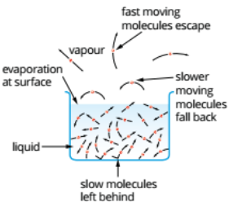

Evaporative cooling

-Evaporation is a change of state that occurs below the boiling point of a substance

-While temperature represents the average kinetic energy of a substance the particles in the substance have a range of kinetic energies with some particles having a much higher than average E_{k}

-Due to their random motion, some of these highly energetic particles can overcome the interparticle forces and escape through the surface of the liquid

-As evaporation results in the loss of the particles with the highest E_{k}, it lowers the temperature (average E_{k}) of the substance

-Volatile substances (those with weaker interparticle forces) will have higher evaporation rates as more particles have enough E_{k} to overcome the interparticle forces
-Evaporation rate also increases with increasing temperature, surface area and wind speed

-Wind increases the net rate of evaporation by carrying away the evaporated particles, preventing them from condensing back into the liquid

-Evaporative cooling explains the cooling action of sweating, evaporative air conditioners and wind chill/fans (although this also involves other factors)

Heating and Cooling

Thermal equilibrium

-When two substances at different temperatures come into thermal contact, heat energy will move from the hotter object to the colder object until they reach thermal equilibrium

-At thermal equilibrium, both objects will be the same temperature

-The exact equilibrium temperature will depend on the masses and specific heat capacities of the two substances, but will be somewhere between the two initial temperatures

-Assuming no changes of state or loss of energy to the surroundings, the equilibrium temperature can be calculated by:

ΔQ_{hot} = ΔQ_{cold}
(as Q = mcΔT) m_{hot}c_{hot}ΔQ_{hot} = m_{cold}c_{hot}ΔQ_{hot}
m_{hot}c_{hot}(T_{hot} – T_{final}) = m_{cold}c_{hot}(T_{final} – T_{cold})

-In heating problems where a change of state occurs, you need will need to take latent heat into account:

Q = mcΔT + mL

Heat and work

-James Prescott Joule’s paddle wheel is an example of a device that transformed mechanical energy into thermal energy

-Other devices such as thermal power stations transform thermal energy into mechanical energy (which can then be transformed into electrical energy)

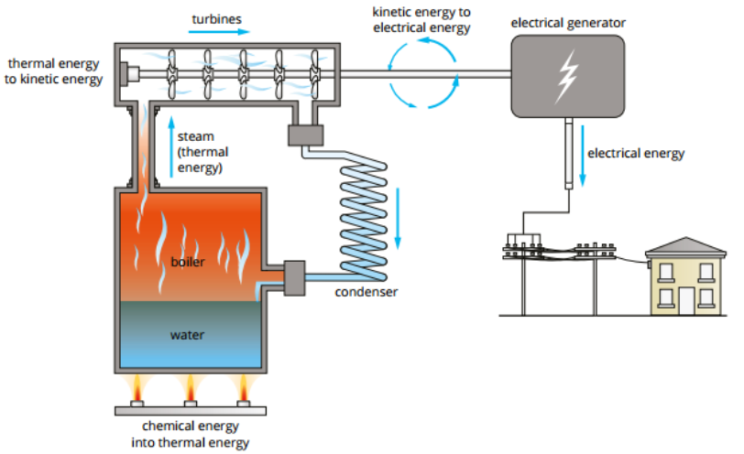

-In these cases, internal energy (U) is transferred from the system doing the work to the system having work done on it

-The energy transferred can be calculated, as the energy lost by one system will be equal to the energy gained by the other:

W = Fs and Q = mcΔT
(as energy gained = work performed) W = Q
Fs = mcΔT

Where F is force in newtons (N) and s is the displacement in metres (m)

Efficiency

-Energy transformations are never 100% efficient

-Some energy is always wasted in undesirable transformations (e.g. a light globe producing heat as well as light)

-The efficiency of an energy transformation can be calculated by:

efficiency (η) = useful energy transformed x 100 = energy output x 100
total energy supplied energy input

Heat Transfer

-Heat can be transferred within an object or between objects by the processes of conduction, convection and radiation

-Each of these transfer methods involves the transfer of heat by a different mechanism, so they must all be considered separately when trying to promote or prevent heat transfer between objects

Conduction
-Conduction is the transfer of heat without the net movement of particles (atoms/ molecules)

-It will occur in all substances, but is most significant in solids

-Conduction can occur by molecular/atomic collisions or by the movement of free electrons

-Particles in a solid possess kinetic energy due to their vibrational motion

-When adjacent particles collide, kinetic energy is transferred from the particle with the greater energy to the particle with the lesser energy

-Conduction by collision transfers heat relatively slowly, due to the low vibrational velocity of the particles

-Metals and some other materials have free (or delocalised) electrons that are able to move throughout the materials

-When a metal is heated, these free electrons also gain kinetic energy

-When electrons gain E_{k}, their velocity increases to a much greater degree due to their lower mass (an electron has ~ 1/1800 the mass of a proton or a neutron)

-These free electrons can move rapidly throughout the material transferring thermal energy as they move
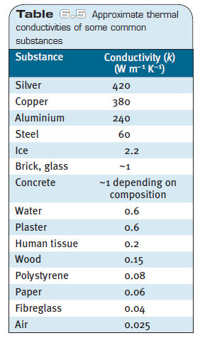
Thermal conductivity

-Thermal conductivity (k) is a measure of a material’s ability to conduct heat

-It has units of watts per metre per kelvin (W m⁻¹ K⁻¹) (note: 1 W = 1 J s⁻¹)

-Materials with a high thermal conductivity are called conductors and materials with a low thermal conductivity are called insulators

-Conductors tend to be substances that can transfer heat by collisions and free electrons

-Insulators do not have free electrons, so all conduction occurs by particle collisions

-Solids tend to be the best conductors of heat as the particles are closer together

-Gases are excellent insulators (poor conductors) as the low density limits the number of collisions between particles

-The rate of conduction in a material increases with:
-increasing thermal conductivity of the material (e.g. nature of the material)
-increasing temperature difference
-decreasing thickness of the material
-increasing surface area

Rate of conduction = Q = kAΔT (not in syllabus)
t L
where Q heat transferred (J), t is tie (s), k is thermal conductivity (W m⁻¹ K⁻¹), A is surface area (m²), ΔT is temperature difference (K or ºC) and L is thickness (m)

Convection

-Convection is the transfer of heat within a fluid (liquid/gas) by the movement of hot parcels of fluid

-Unlike convection, it involves the mass movement of particles over a distance

-When a fluid is heated, its particles gain kinetic energy causing the particles to move more rapidly and pushing the particles further apart
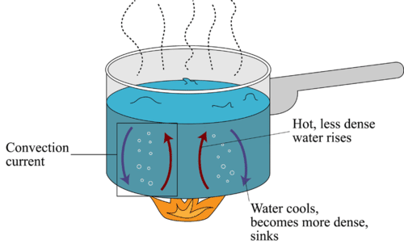

-This decreases the density of the hotter portion of the fluid

-Less dense, hotter fluid will rise up and denser, colder fluid will fall down to replace it

-The upward movement of hot fluid and downward movement of cold fluid is called a convection current

-Fluids are heated most effectively by placing the heat source at the bottom of the container so that convection currents continually move hot fluid up and away from the heat source and cold fluid down towards it

-The rate of convection increases with:
-increasing temperature difference between the heat source and the convective fluid
-increasing surface area of contact between the heat source and the convective fluid

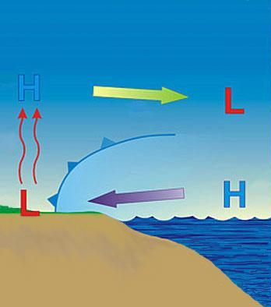
Natural convection

-Natural convection occurs when a fluid rises as it is heated

-An example of this is the natural convection that leads to land and sea breezes

-Air above the land is more susceptible to temperature changes than the air above the ocean

-This is because the waters high heat capacity keeps its temperature relatively constant

-During the day, the air above the land heats up and rises
-This air is replaced by cooler, denser air from above the ocean (a sea breeze)
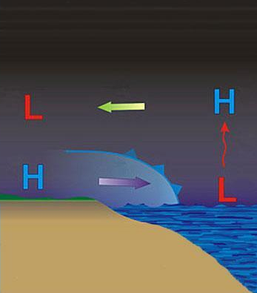

-At night, the reverse process occurs as the land cools down

-Warmer air above the ocean rises and is replaced by the cooler denser air form above the land (a land breeze)

Forced convection

-Forced convection occurs when a fluid is heated and then blown by a fan

-Examples of forced convection include ducted heating and fan forced ovens

Radiation

-Conduction and convection require a medium (e.g. matter) to transfer heat

-Radiation is the only method of heat transfer that can occur without a medium

-Life on earth would not exist unless thermal energy could travel through the vacuum of space

Electromagnetic spectrum

-In the context of heat transfer, radiation refers to electromagnetic radiation

-Electromagnetic radiation consists of electromagnetic waves that travel at the speed of light

-The properties of the waves depend on their wavelength and frequency, with higher energy waves having a shorter wavelength and higher frequency

-The electromagnetic spectrum is the name given to all forms of electromagnetic radiation, including visible light
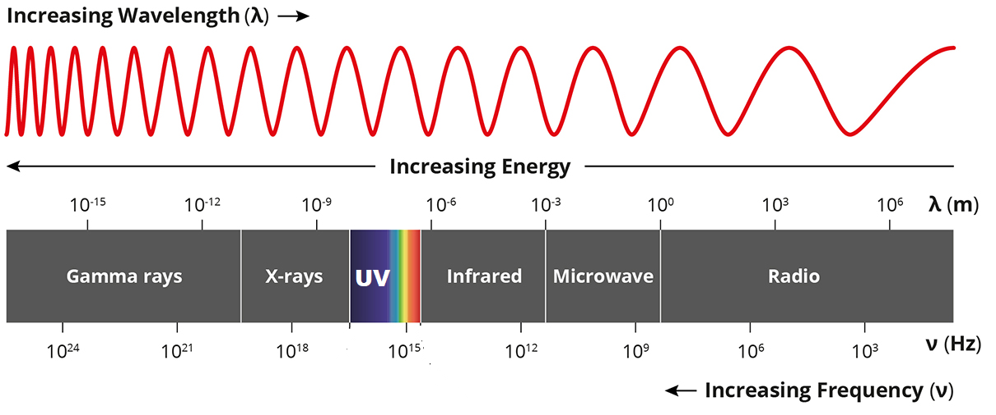

Emission and absorption of radiation
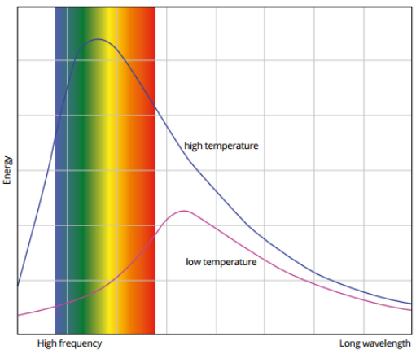

-All objects with a temperature above O K will emit electromagnetic radiation

-The spectrum of frequencies emitted depends on the temperature of the object

-The hotter an object is, the higher the frequencies it will emit e.g. humans emit in the infrared range whereas hotter objects will emit in the range of visible or UV light

-Objects can also gain thermal energy by absorbing electromagnetic radiation

-An objects temperature will increase if it absorbs a greater amount of radiation than it emits, and it will decrease if it emits a greater amount than it absorbs

-While all objects will emit and absorb radiation to some extent, the rate of radiant transfer depends on the following factors:

-Surface area: the rate of radiant transfer increases with increasing surface area

-Temperature: the rate of radiant transfer increases as the temperature difference between the absorbing/emitting object and its surrounding increases

-Wavelength of the incident radiation: different coloured surfaces absorb different wavelengths to a greater extent

-Surface colour and texture: rough, matt black surfaces absorb to a much greater extent than smooth, shiny white surfaces

-The characteristics that make an object a good emitter also make it a good absorber
Applications of radiant heat transfer
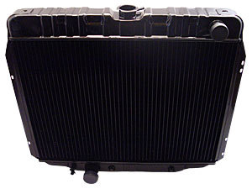

-Cars have a radiator to remove heat from their engines cooling system

-Coolant passes through the engine where it gains thermal energy from the engine block by conduction before the hot coolant is pumped to the radiator

-The radiator is often painted matt black to maximise the rate of emission of radiant energy

-Life on earth is made possible by the radiant energy it receives from the sun

-Emergency blankets have a silvered surface to prevent loss of body heat by radiation

